**Mongodb Sharding Homework**

(Note: couldn't capture all the screenshots)

1. **Start the config server instance**

mkdir -p ~/data/configdb

1. **Start the server**

mongod --configsvr --dbpath ~/data/configdb --port 27011 &

1. **Start the query router**

mongos --configdb localhost:27011 --port 27021 &

1. **create mongodb instances**

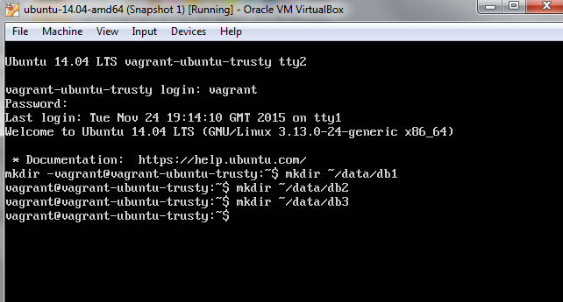

1. **Start mongodb servers for each shard**

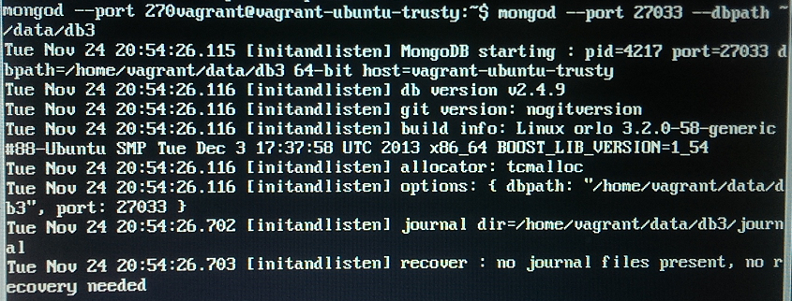

1. **Registering Shard**

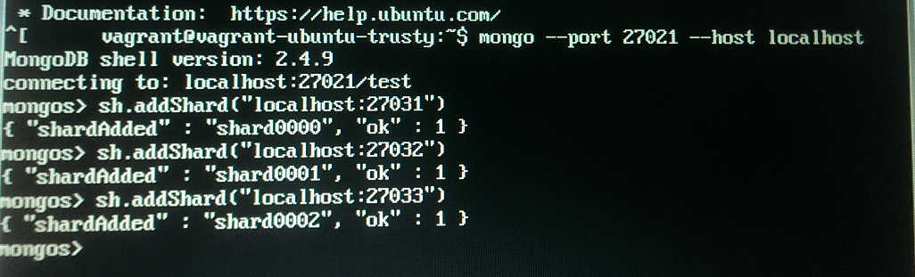

1. **Enabeling sharding on the database**



1. **Shard the collection on a key**

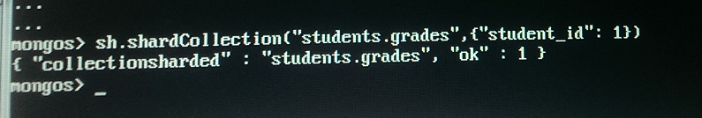

1. **Check the status**

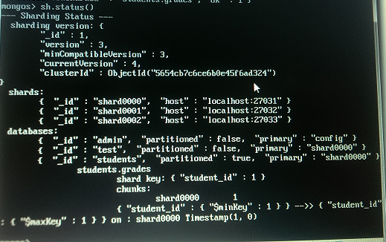

1. **Add some data**

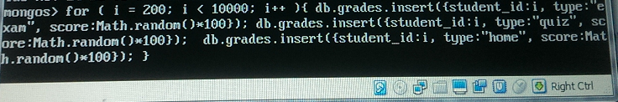

1. **Observe sharding status**

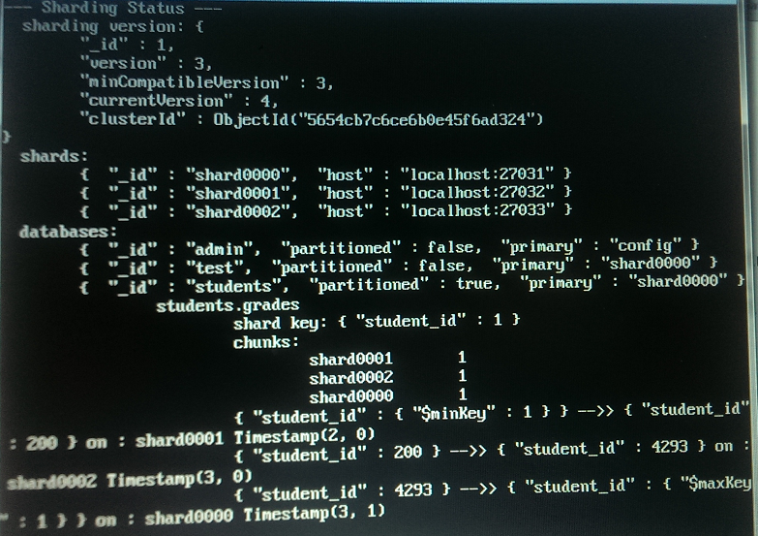

1. **Connect to the individual shards**

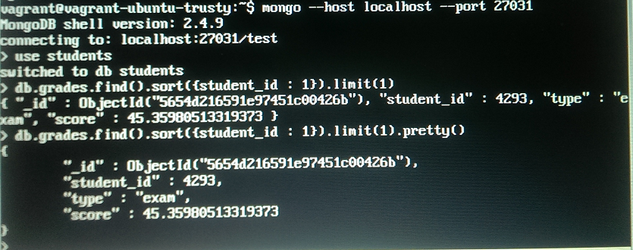

1. **Connect to the entire cluster**

